

Holy Trinity C of E Primary
NEWSLETTER –14th March 2025
www.holytrinitycofeseatoncarew.co.uk

E-mail: admin@hpoolholytrinity.org.uk
Love Your Neighbour
As Yourself

Dates for Your Diary
19th March Church
11th April School Closes for Easter Holidays
28th April School Opens
5th May School Closed Bank Holiday
23rd May School Closes for Half Term
9th June School Opens
18–20th Jun Y6 Edinburgh Residential
3^{rd -}4th July Y4 Camping
21st July School Closes for Summer

Comic Relief Red Nose Day
To celebrate 40 years of Comic Relief on Friday 21st March, children are invited to come into school dressed in 80’s inspired clothing. Please do not feel that you need to buy anything new – think double denim, sports clothes or leg warmers! We look forward to seeing everyone’s 80’s inspired outfits. If you wish to kindly make a donation for comic relief please use the following link https://app.parentpay.com/ParentPayShop/Foc/Default.aspx?shopid=17698
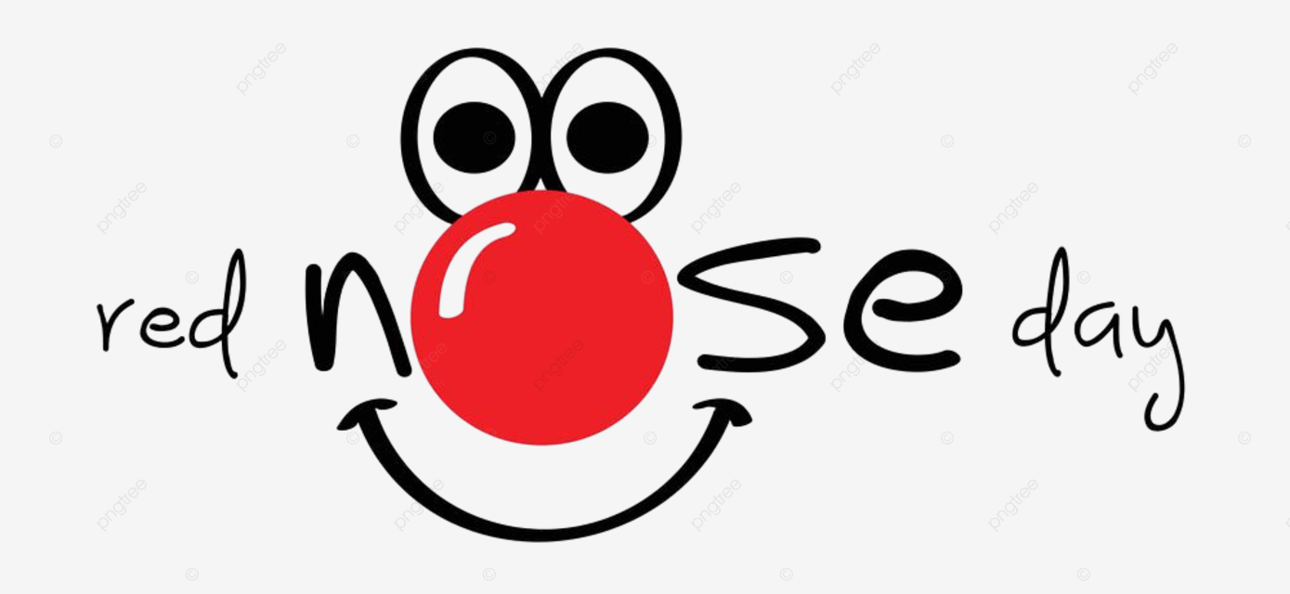

Grapes
If your child brings grapes for snack or packed lunch, can we please ask that that they are sliced in half, length ways, to reduce choking hazards.

Poster Competition - British Science Week 2025
We would like to say a huge well done to all of the children who entered our poster competition for British Science Week 2025. We have been inundated with so many amazing designs and can tell how much time and effort has gone into the posters at home. Each poster was unique, creative and informative. Every class got the chance to visit the hall today, where the posters were displayed, to see everyone's hard work. Well done to our class winners. It is clear to see we have many aspiring scientists here at Holy Trinity.

Year 5 and 6 Boys Football
Today some of our Y5/Y6 boys took part in a Primary Football Cup, which was held at Brierton’s all weather pitches. Unfortunately we never got placed but the boys showed great sporstmanship and team spirit. There were some good shots taken and some great goals saved and all played to their best ability. Well done to the boys who took part, they were a credit to our school.

